

Sara and her family moved into a new house. The house was big and empty. Sara felt a little scared. But her parents told her it would soon feel like home.

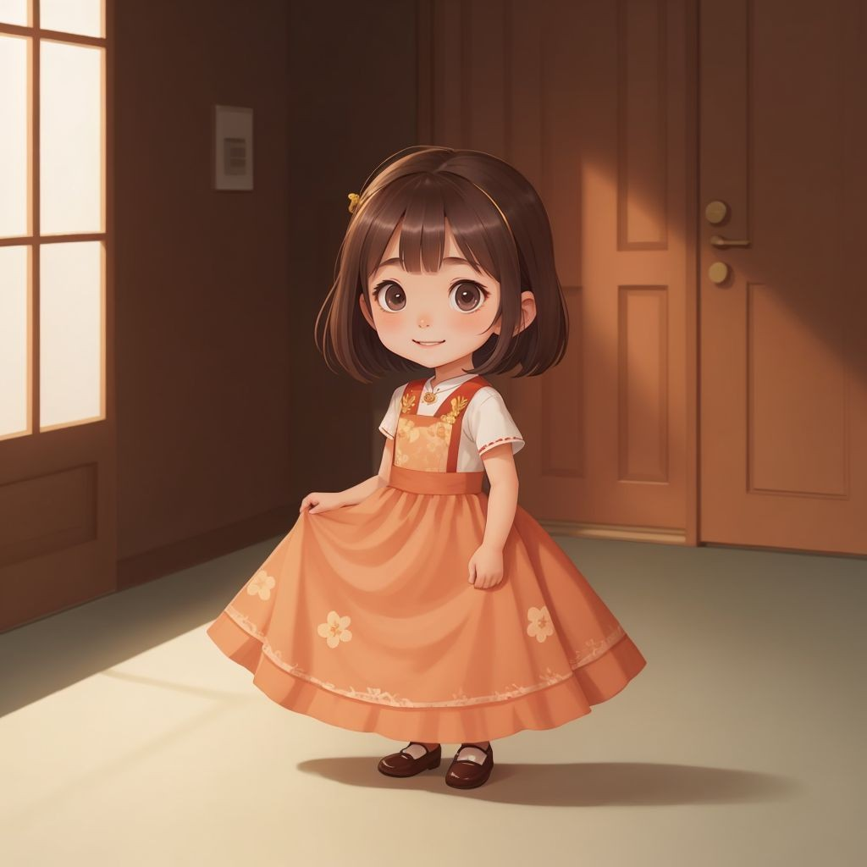

Sara and her parents started unpacking their boxes. They found their favorite books and toys. Sara's mom made her favorite cookies. The house began to feel warmer and cozier.

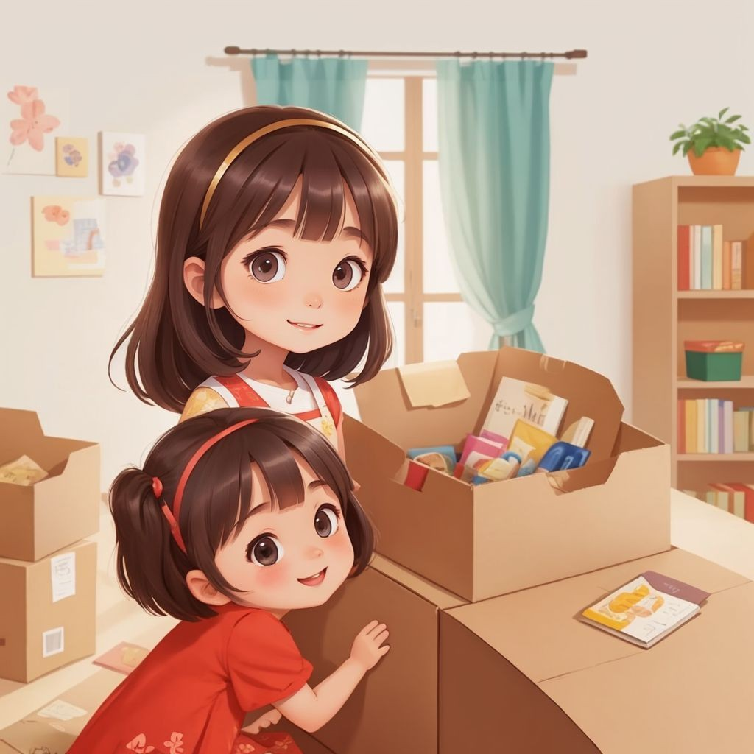

Every night, Sara's dad read her a bedtime story. She loved hearing about magical lands and brave heroes. It made Sara feel safe and happy. Soon, bedtime became her favorite part of the day.

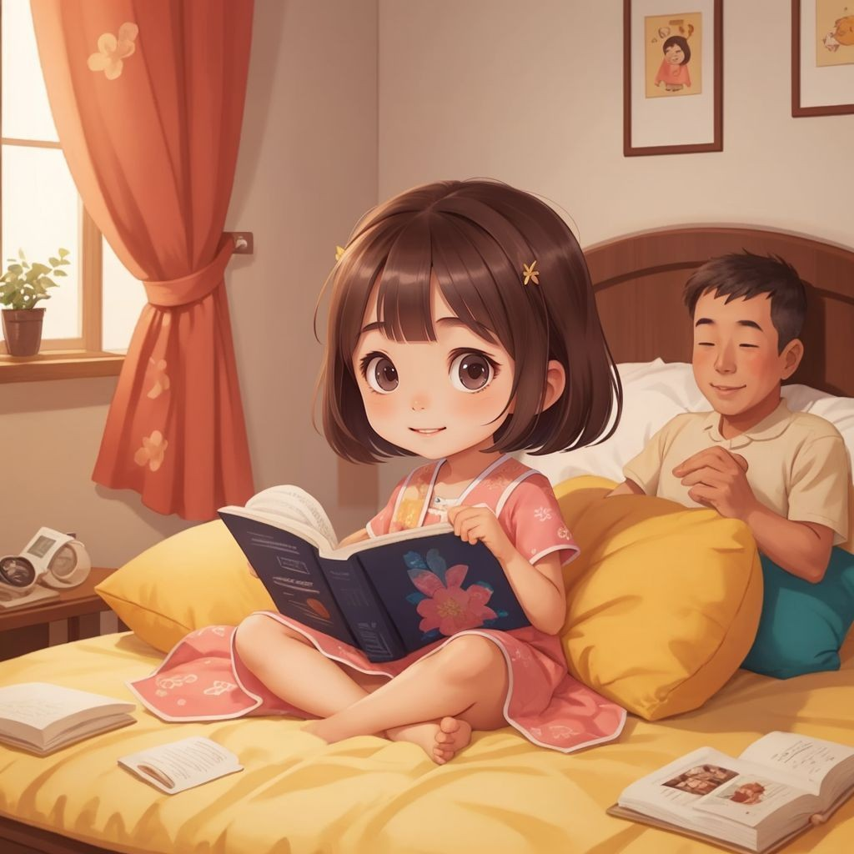

One day, Sara and her mom decided to bake a cake. They mixed flour, sugar, and eggs together. Sara got to lick the spoon. They laughed and made a delicious mess.



Sara's dad showed her how to plant flowers in the garden. They dug holes and put seeds in the ground. Sara watered the plants every day. Soon, the garden was full of colorful flowers.

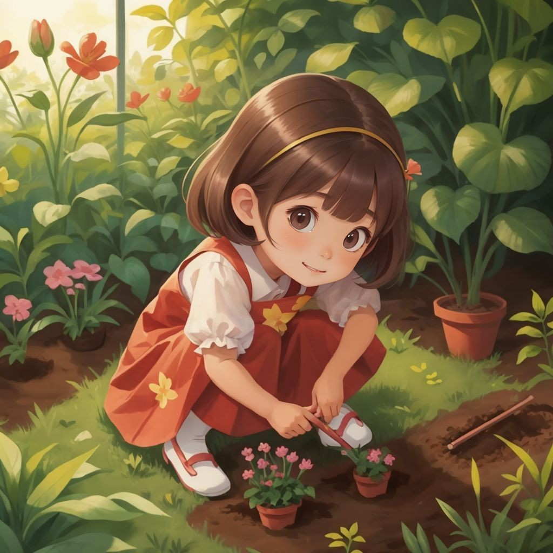

One evening, Sara's family had a movie night. They watched a funny movie and ate popcorn. Sara snuggled between her mom and dad. It was a perfect night full of giggles.



Sara's family loved playing board games together. They played games like Monopoly and Scrabble. Sara learned new words and strategies. Everyone cheered and had a great time.

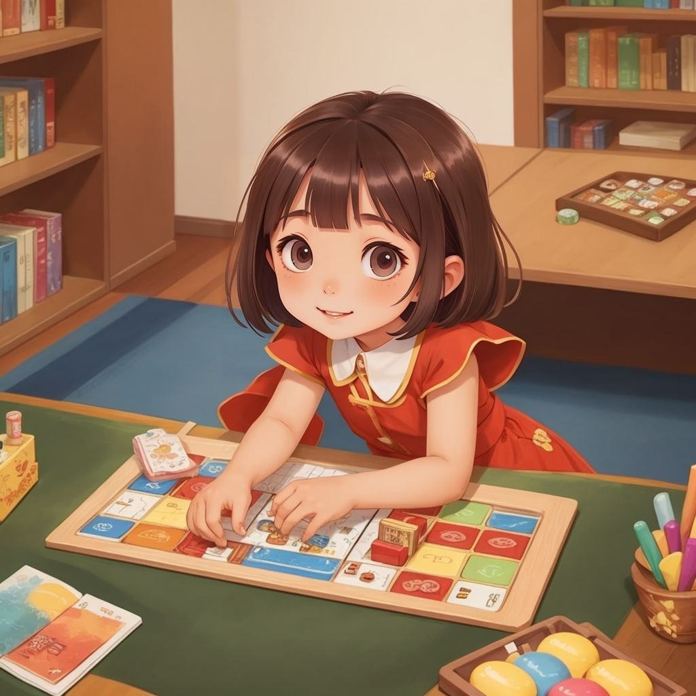

After many days of fun and laughter, Sara realized something. The house was no longer just a house. It was a home full of love and happiness. Sara knew she was exactly where she belonged.

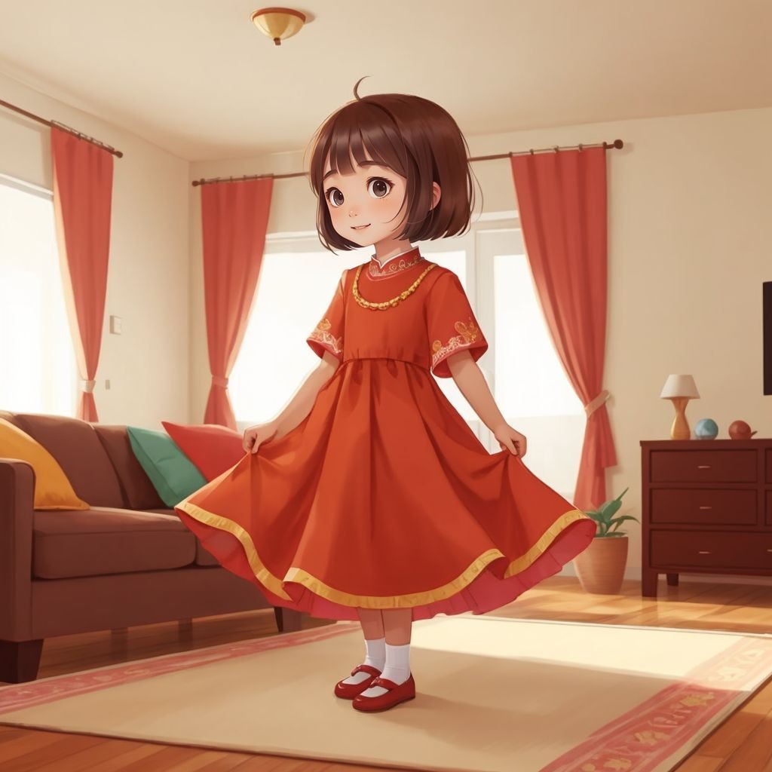

SPARK YOUR CHILD's IMAGINATION

AND CREATE PERsONALIZED CHILDREN's BOOKs WITH CHILDBOOK.AI!

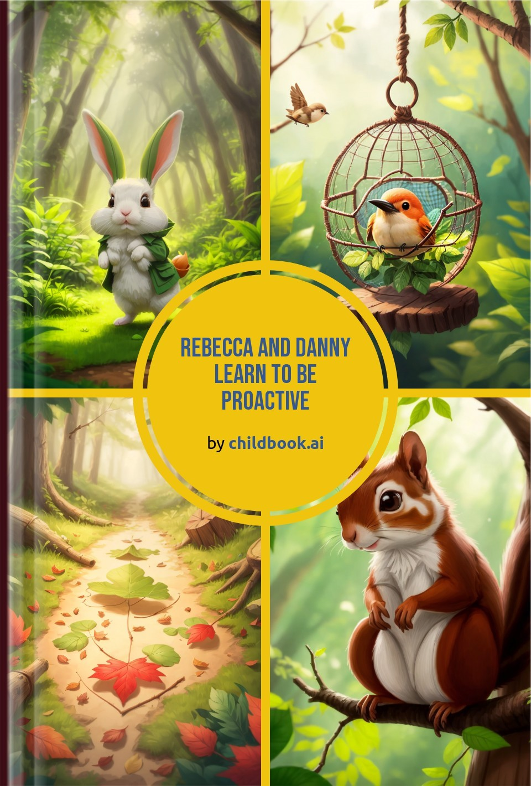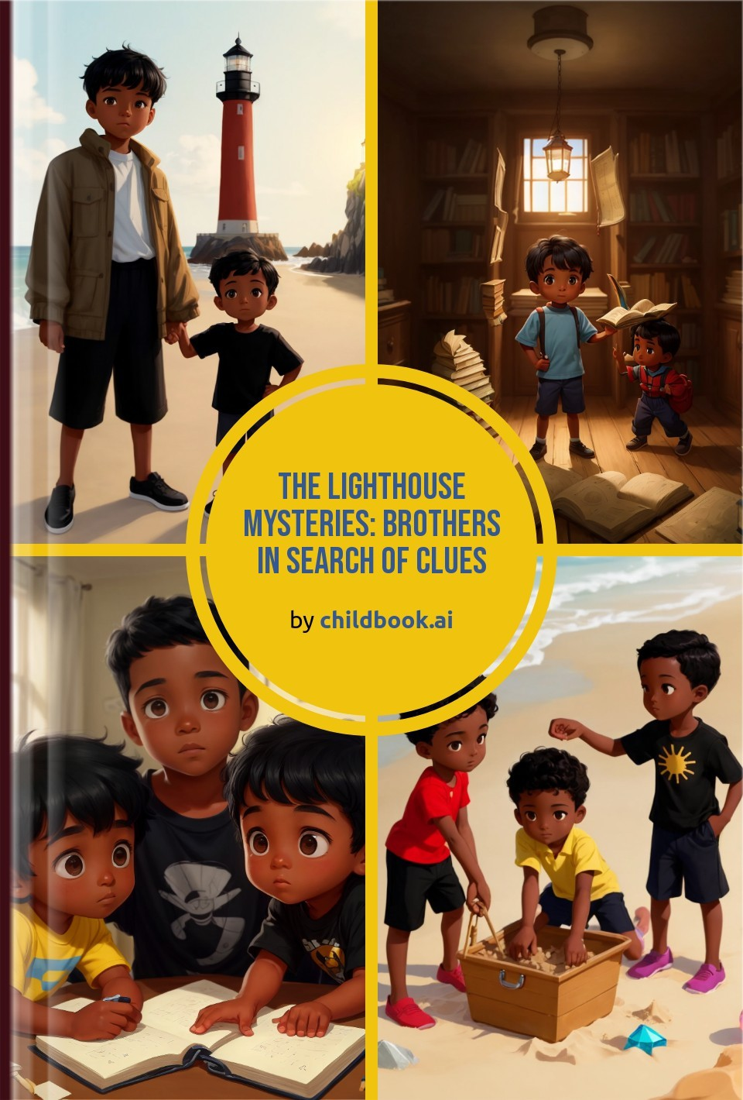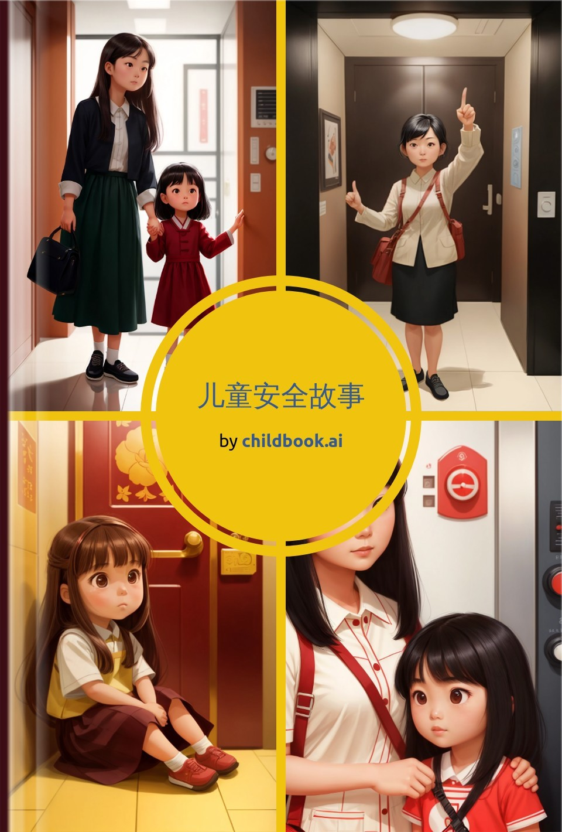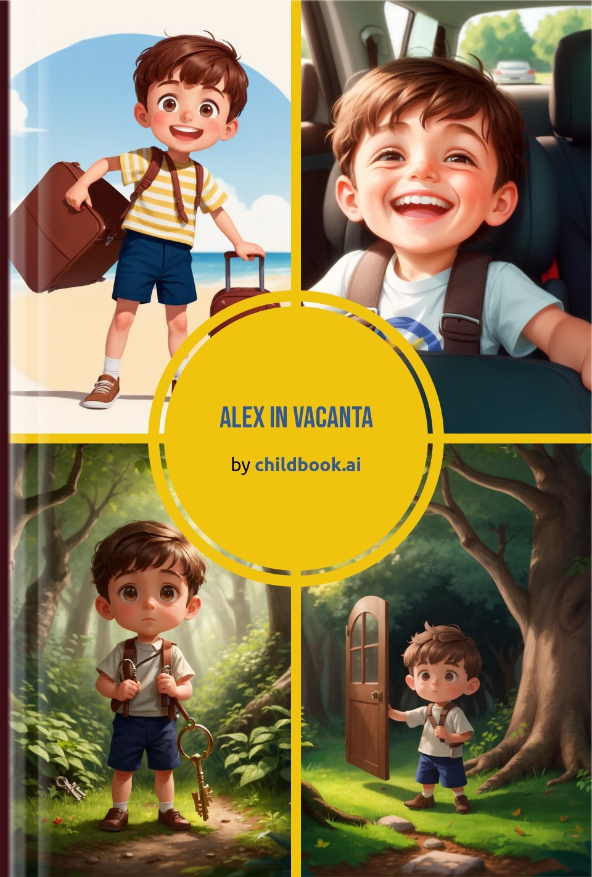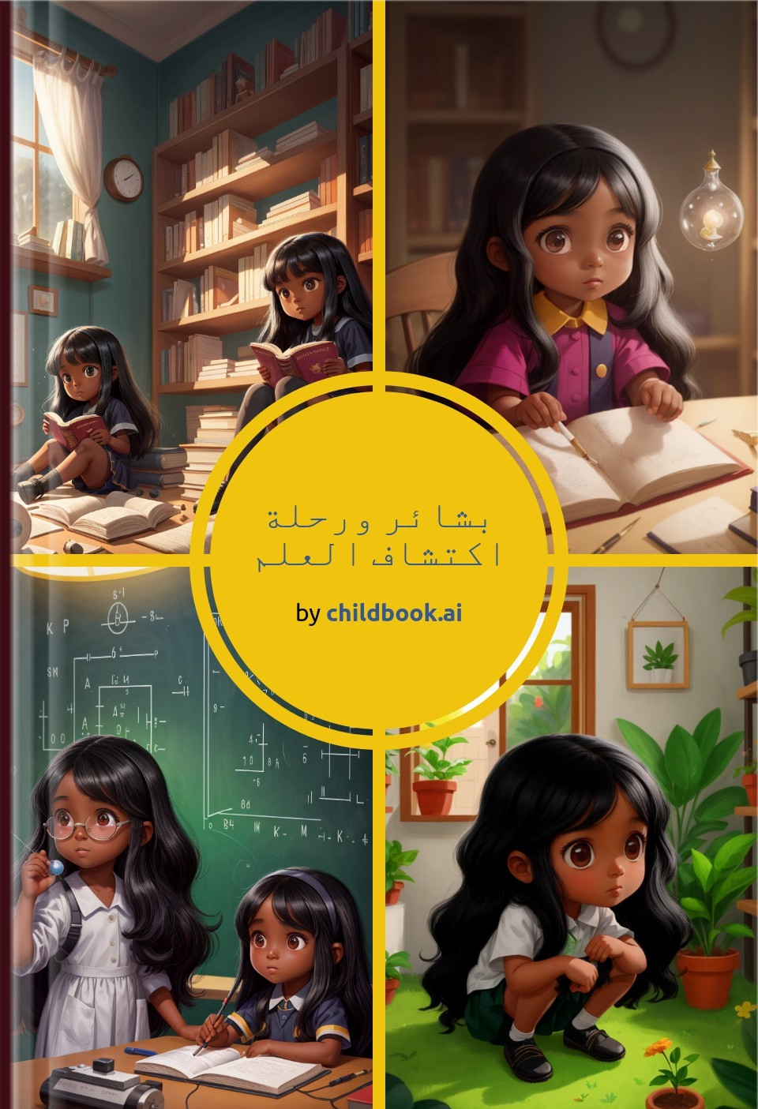

Create a unique children's story with our easy-to-use ai storybook maker. Our personalized children's books are fully customized with original characters, illustrations, and an imaginative plot.